**CTF Topic: Analyzing APK - com.hamropatro**



**1. Introduction**



Explore the APK file `com.hamro patro` using the provided details.

**2. Tools and Requirements**

Access to the internet open the link: [sisik.eu/apk-tool](http://sisik.eu/apk-tool)

Upload this file: <https://zippyshare.day/9luzQAMUPBdjXry/file>

**3. Scenario**



Analyse the APK file `com.hamro patro` to answer questions about its components and details.

**4. Process to follow while performing CTF**

**Step 1:** open this link <https://zippyshare.day/9luzQAMUPBdjXry/file> and download it.   
**Step 2:** Upload the downloaded file by opening this link: [sisik.eu/apk-tool](http://sisik.eu/apk-tool)

**Questions**

Flag 1: What is the package name of the APK file?

Answer: com.hamropatro

Flag Captured.

Flag 2: What is the `versionCode` of the APK file?

Answer: 1034

Flag Captured.

Flag 3: What is the `versionName` of the APK file?

Answer: 9.8.4

Flag Captured.

Hint

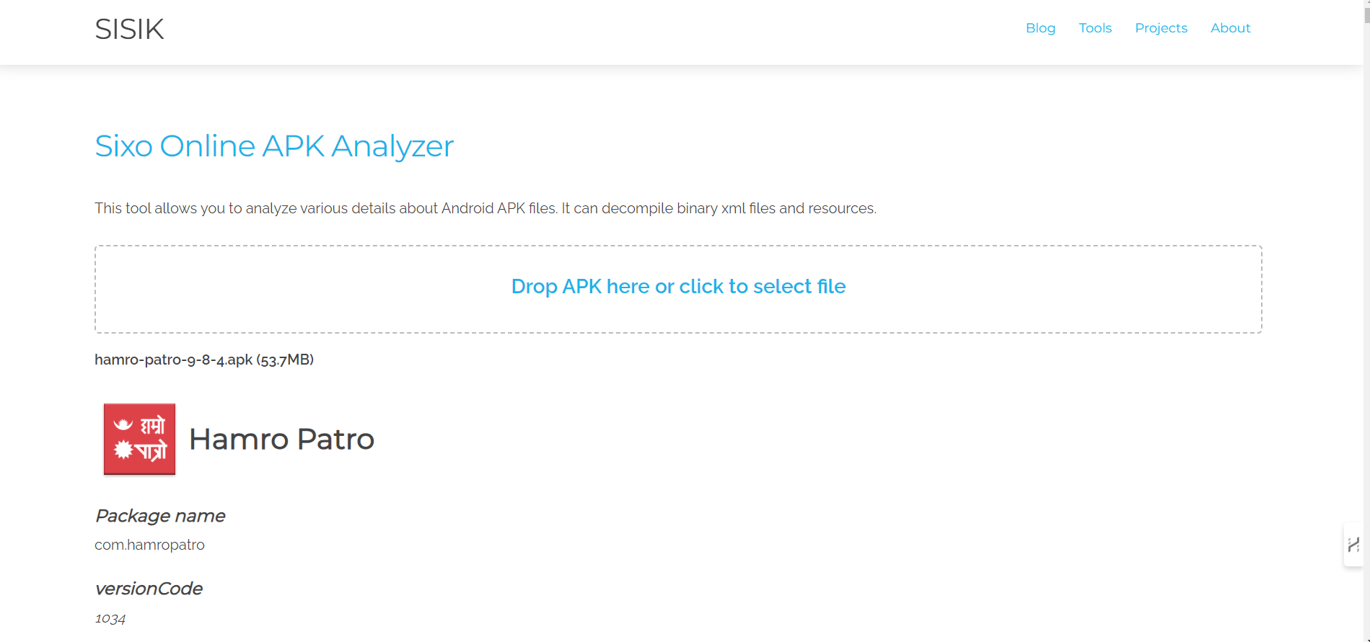

Use the provided web-based tool to explore the APK file and verify each answer based on the details given about the `com.hamropatro` APK.